Lab-Project 5: Viewing Segments and Clusters with a Hex Editor
What You Need for This Project
- A virtual machine running Windows XP. Other operating systems might work, but the procedure will be different.
Starting your Virtual Machine
Start your virtual machine as you did in a previous Lab.
In the virtual machine, click Start, "Turn Off Computer", "Turn Off". Wait until the guest operating system shuts down.
Adding a Small Hard Disk to your Virtual Machine
Start VMware Player again. On the right side, you see a Windows XP Professional virtual machine in a State: of "Powered Off", as shown, e.g. below.
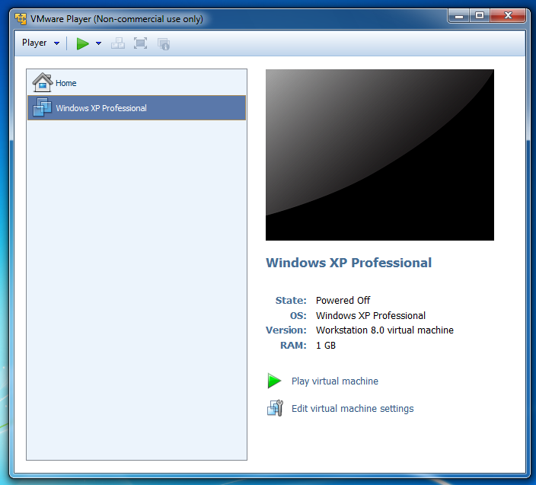
On the right side, click "Edit virtual machine settings".
In the "Virtual Machine Settings" box, click the Add... button. If a "User Account Control" box pops up, click <b<yes< b="">.</b<yes<>
In the "Add Hardware Wizard" box, accept the default selection of "Hard Disk" and click the Next button, as shown, e.g. below:
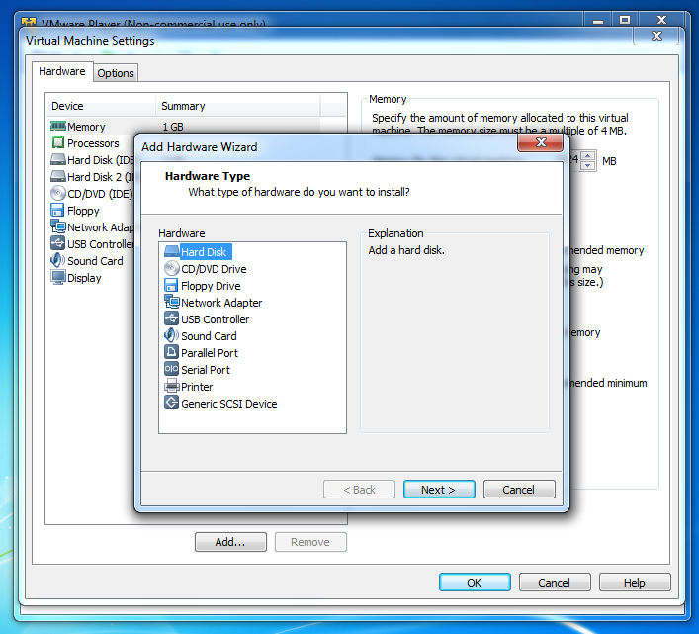
In the "Select a Disk" box, accept the default selection of "Create a New Virtual Disk" and click the Next button.
In the "Select a Disk Type" box, accept the default selection of "IDE (Recommended)" and click the Next button.
In the "Specify Disk Capacity" box, set the "Maximum disk size (GB)" to 0.1 and check the "Allocate all disk space now" as shown, e.g. below. Click Next.
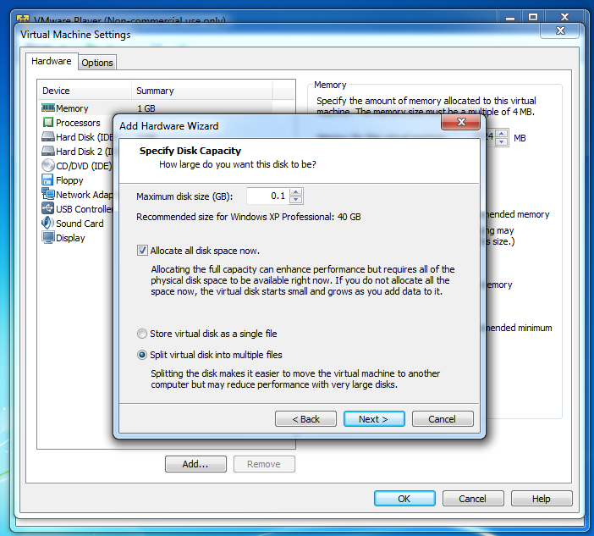
In the "Specify a Disk File" box, accept the default selection and click Finish. In the "Virtual Machine Settings" box, click OK.
Starting Your Virtual Machine
In the VMware Player window, on the right side, click the "Play virtual machine" link.
Downloading and Installing HxD
In your virtual machine, start a Web browser and go to http://mh-nexus.de/en/hxd
Scroll down and click the "Download page" link. Download and install the English version of HxD. Accept the default options.
Examining a New Disk
In your virtual machine, if HxD is not open, click Start, "All Programs", "HxD Hex Editor", HxD.
In HxD, click Extras, "Open disk...".
In the "Open disk" box, in the "Physical disks" section, click "Hard Disk 2", as shown, e.g. below. Click OK.
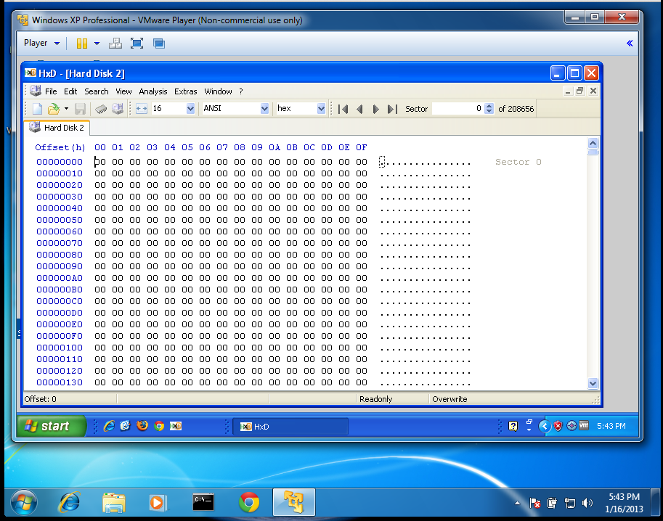
HxD shows the contents of the disk, as shown, e.g. below on this page.
Find these things:
- Each horizontal row shows 16 bytes, labeled with the Offset (h) value in hexadecimal at the top.
- On the left, the byte value is shown in hexadecimal. On the right, it's shown in ASCII.
- Because this is a new hard disk, every byte is zero. There is no information at all on this disk.
- In the upper right, notice that you are viewing "Sector 0 of 208656". Each sector contains 512 bytes, so that is a total of 208,656 x 512 bytes = 106,831,872 bytes. This is approximately 100 million bytes, or 0.1 GB.
Initializing the Disk
In your virtual machine, click Start. Point to "My Computer" and right-click. Click Manage. In the left pane of "Computer Management", click "Disk Management". The "Initialize and Convert Disk Wizard" pops up. Click Next, Next, Next, and Finish. This writes a Master Boot Record to the disk.
The disk should now appear in Disk Management as "Disk 1", containing approximately 100 MB of Unallocated space, as shown, e.g. below.
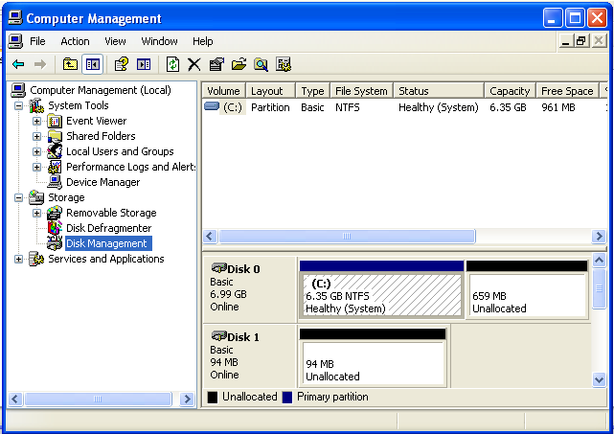
Viewing the Master Boot Record (MBR)
In HxD, click View, Refresh. Nonzero values should now be visible on the disk, as shown, e.g. below.
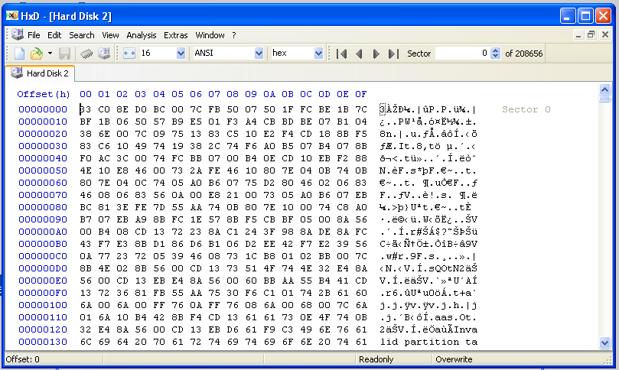
Scroll down to the end of the first sector, locations 1FE and 1FF, and note that the last two bytes are 55 and AA, as shown below. Bytes 200 and above still contain zeroes.
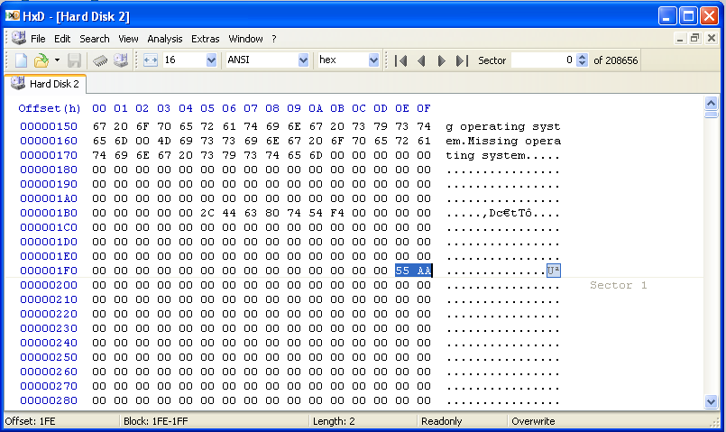
The chart below shows the main features of the MBR (from Wikipedia).
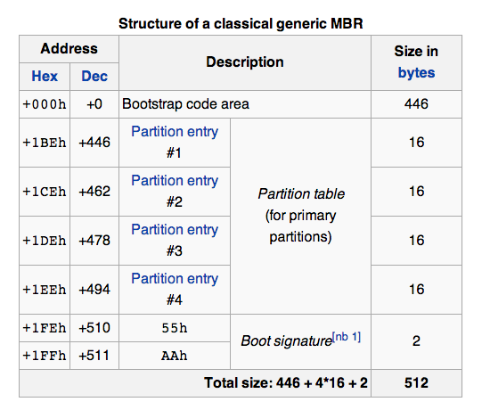
Find these features in your HxD window:
- Start of Partition Table: Locations 01BC and 01BD contain zeroes
- Partition Table: Locations 01BE through 01FD contain 64 bytes of zero. These are four 16-byte records, which specify the four possible partitions on a Basic Disk. Since there are no partitions on the disk, they are all zero now.
- End of Boot Sector: Locations 01FE and 01FF contain 55 and AA. This is the MBR Signature--it marks the end of the MBR, and also the end of the Partition Table.
Partitioning the Disk
In your virtual machine, in "Disk Management", right-click the "94 MB Unallocated" area of Disk 1 and click "New Partition".
In the "Welcome to the New Partition Wizard" box, click Next.
In the "Select Partition Type" box, accept the default selection of "Primary partition" and click Next.
In the "Specify Partition Size" box, enter a Partition Size of 8 as shown, e.g. below, and click Next.
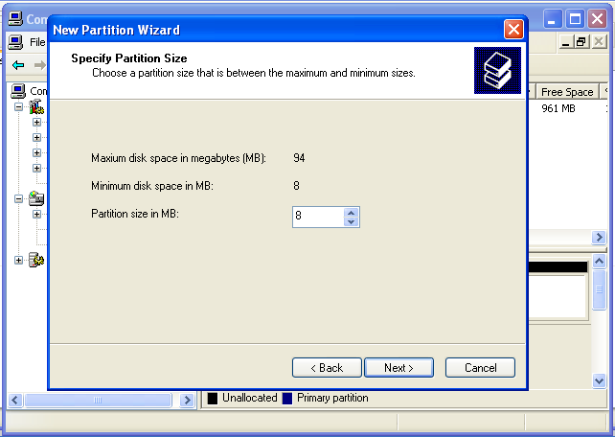
In the "Assign Drive Letter or Path" box, accept the default selection of E and click Next.
In the "Format Partition" box, set the "Allocation unit size" to 4096, as shown, e.g. below, and click Next.
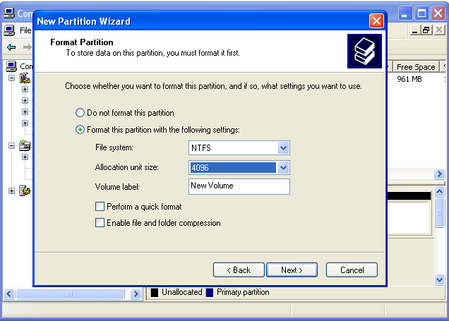
In the "Completing the New Partition Wizard" box, click Finish.
After a few seconds, Disk Manager should now show New Volume (E:) new volume with a size of 8 MB, as shown, e.g. below.
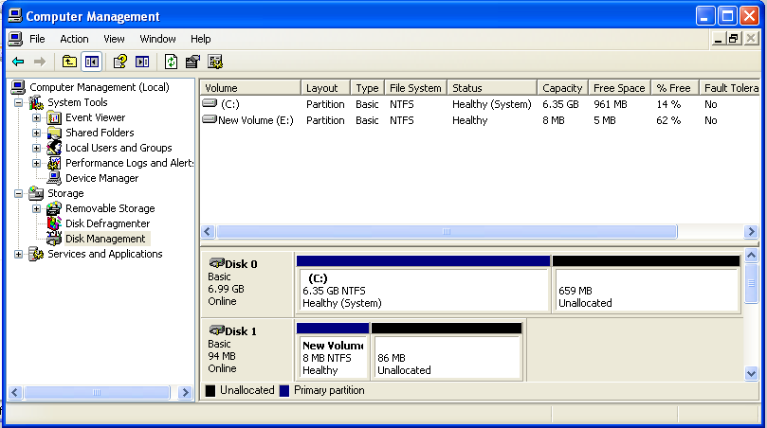
Viewing the Partition Table
In HxD, click View, Refresh.
Notice that the first record of the partition table (from hex 01BE through 01CD) now contains data, as highlighted in the image, e.g. below on this page.
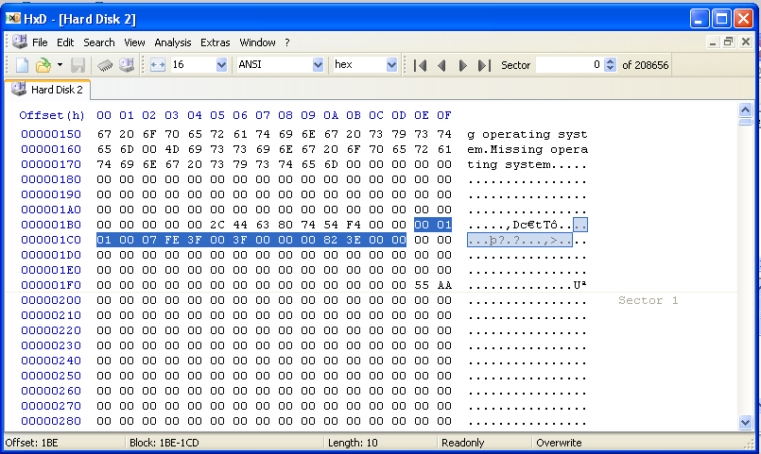
Filling the E: Partition with Spam
Download file SPAM.zip (or Lab-Proj.05_SPAM.zip from the instructor).
Download file EGGS.zip (or Lab-Proj.05_EGGS.zip from the instructor).
Right-click the SPAM.zip file and click "Extract All...".
In the "Welcome to the Compressed (zipped) Folders Extraction Wizard" box, click Next.
In the "Select a Destination" box, enter a directory of E:, as shown below. Click Next.
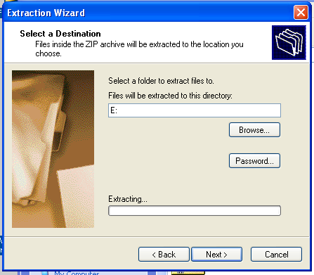
After a few seconds, an error message pops up, saying "There is not enough space on the disk to extract the file". Click OK.
In the "Extraction Wizard" box, click Cancel.
From the virtual machine's desktop, click Start, "My Computer".
Double-click "New Volume (E:)".
Double-click the SPAM folder to open it.
You see a lot of files named spam1001.txt, spam1002.txt, etc.
Double-click spam1001.txt.
As you can see, the file contains the word SPAM repeated many times, as shown, e.g. below. Each "spam" file contains 10,000 characters.
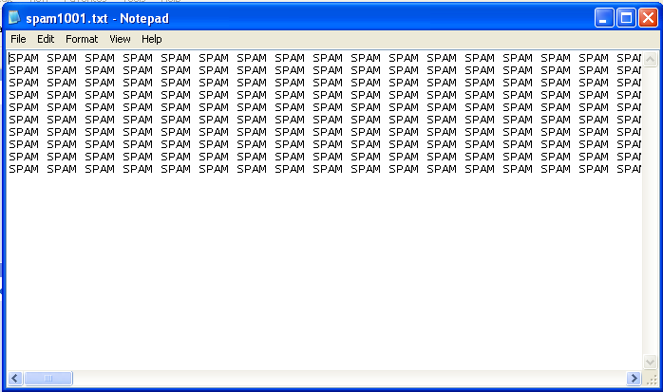
Viewing the Stored SPAM Data
In HxD, click View, Refresh.
Scroll down with the mouse until you find some SPAM.
Scroll back up carefully to the start of a block of SPAM. The exact location may vary. When I did it, the spam started at sector 671, as shown, e.g. below on this page.
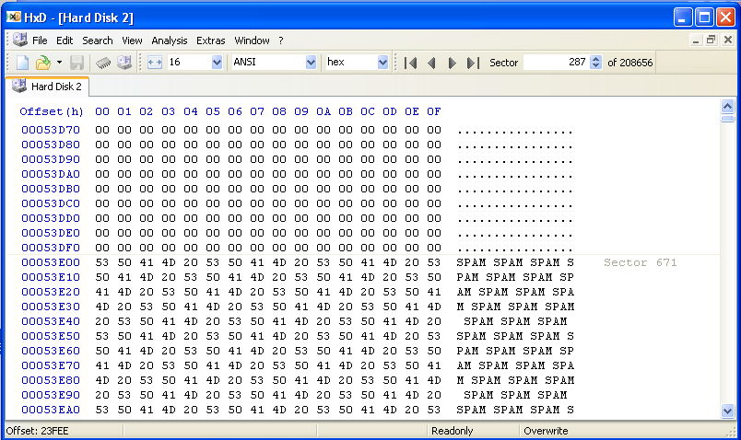
Tap the PageDown key on the keyboard until you reach the end of the SPAM text in this file. When it was done, the text ended in sector 714, as shown, e.g. in the image below on this page.
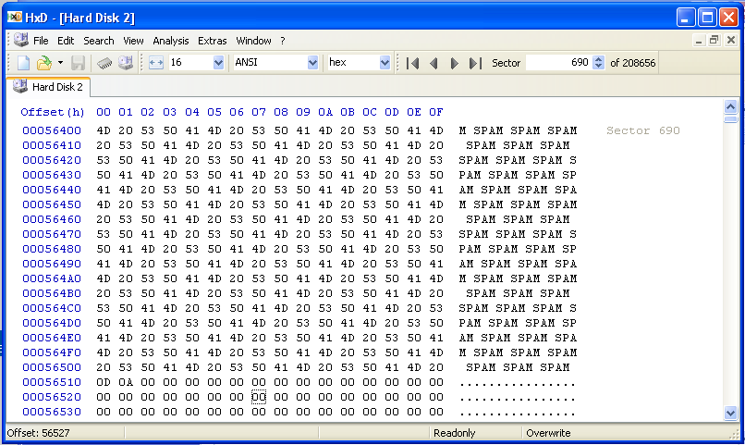
The partition is formatted with 4096-byte clusters, each containing eight 512-byte sectors. The spam files contain 10,000 characters each, so they occupy three clusters, as shown below. Look at these clusters and verify that they contain the expected data. Your Sector numbers might be different, but you should see this pattern of data in 24 sequential sectors.

CLUSTER 1 CLUSTER 2 CLUSTER 3
--- ---- --- ---- --- ----
671 SPAM 679 SPAM 687 SPAM
672 SPAM 680 SPAM 688 SPAM
673 SPAM 681 SPAM 689 SPAM
674 SPAM 682 SPAM 690 SPAM + 0
675 SPAM 683 SPAM 691 0
776 SPAM 684 SPAM 692 0
777 SPAM 685 SPAM 693 0
778 SPAM 686 SPAM 694 0
Deleting the Files on the E: Drive
In your virtual machine, click Start, "My Computer".
Double-click "New Volume (E:)".
Right-click the SPAM folder and click Delete.
In the "Confirm Folder Delete" box, click Yes.
Another "Confirm Folder Delete" box pops up, saying that these files will be "permanently deleted". Click Yes.
Viewing the SPAM Data
In HxD, click View, Refresh.
Scroll through the 24 sectors you examined previously, and verify that all the SPAM text is still there. Deleting the files did not erase any text data.
All it did was change records in the Master File Table.
Formatting the E: Drive
In your virtual machine, click Start, "My Computer".
Right-click "New Volume (E:)" and click Format....
In the "Format New Volume (E:)" box, make sure that the "Quick Format" box is cleared, and that the "Enable Compression" box is cleared, as below. Click Start. A "Format New Volume (E:)" box pops up saying "WARNING: Formatting will erase ALL data on this disk". Click OK.
When the message "Format Complete" appears, click OK.
Viewing the SPAM Data
In HxD, click View, Refresh.
Scroll through the 24 sectors you examined previously, and verify that all the SPAM text is still there. Formatting the disk did not erase any text data either.
Adding "EGGS" Files to the E: Partition
Right-click the EGGS.zip file and click "Extract All".
In the "Welcome to the Compressed (zipped) Folders Extraction Wizard" box, click Next.
In the "Select a Destination" box, enter a directory of E:. Click Next.
When the extraction completes, click Finish.
A "New Volume (E:)" window opens.
Double-click the EGGS folder to open it.
Double-click the EGGS folder to open it.
You see a lot of files named "Copy (2) of eggs1001.txt", etc. Double-click one of the files to open it.
As you can see, the file contains the word EGGS repeated many times, as shown below. There are a total of 1000 characters in each "eggs" file, much smaller than the "spam" files.
Viewing the EGGS Data
In HxD, click View, Refresh.
Scroll through the 24 sectors you examined previously, and find some EGGS data. If necessary, use the mouse to scroll, or the "Search" menu item, to find some EGGS text. Find the place where the EGGS data ends, as shown, e.g. below.
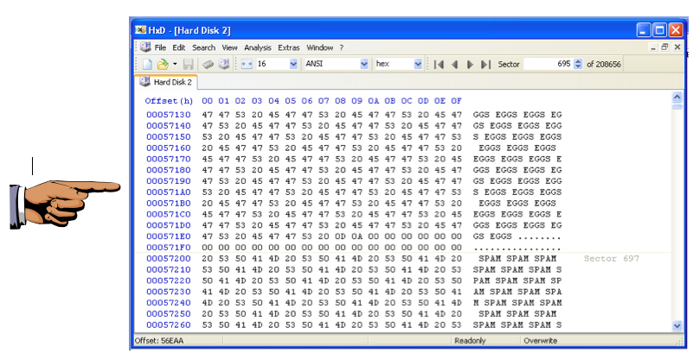
Reflection
This single image shows three essential concepts:
- Active data: the EGGS text is part of a file referenced in the Master File Table
- RAM Slack: The 22 Zeroes at the end of the EGGS data contain zeroes when written by modern operating systems. However, in Windows versions prior to Win 95 Version B, this area contained data from RAM, which could potentially contain passwords or other confidential information.
- File Slack: the SPAM text at the end of the "eggs" file is old data, left within active clusters
Saving a Screen Image
Make sure your screen shows the three essential items: the EGGS text, the Zeroes, and the SPAM text.
Click the taskbar at the bottom of your host Windows 7 desktop, to make the host machine listen to the keyboard, instead of the virtual machine.
Press the PrintScrn key in the upper-right portion of the keyboard. That will copy the whole desktop to the clipboard.
YOU MUST SUBMIT A FULL-SCREEN IMAGE TO GET FULL CREDIT!
On the host machine, not the virtual machine, open Paint and paste in the image.
Save the image with the filename "Your Name Lab-Proj 5a". Use your real name.
Observing the Sectors
Scroll through the sectors, and make sure they show the pattern shown in the chart below. Your Sector numbers may be different, but there should be three sequential sectors with these contents.

Sector Contents Technical Term
------ -------- -----------------------
695 EGGS Active data
696 EGGS + 0 Active data + RAM Slack
697 SPAM File Slack

Make sure you understand the Terms for each type of data.
Zeroing the Disk
Now we will use a tool that can really erase the disk: DISKPART.
In the Windows XP virtual machine, close all windows, except the HxD window.
Click Start, Run.
In the Run box, type CMD and press the Enter key.
In the Command Prompt window, type this command and then press the Enter key:
DISKPART
In the Command Prompt window, type this command and then press the Enter key:
LIST DISK
You should see two disks, as shown below on this page. Disk 0 is the system disk containing Windows XP. Disk 1 is the 100 MB disk we want to erase.
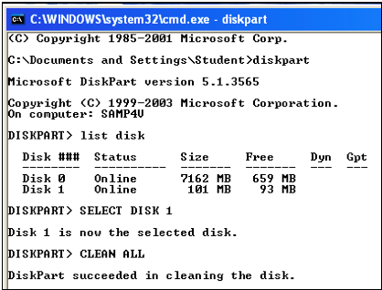
In the Command Prompt window, type this command and then press the Enter key:
SELECT DISK 1
Verify that the message says "Disk 1 is now the selected disk." BE CAREFUL when using this tool--if you erase the wrong disk, it's GAME OVER. In the Command Prompt window, type this command and then press the Enter key:
CLEAN ALL
Viewing the Zeroed Disk
In HxD, click View, Refresh.
All the SPAM and EGGS text is now gone.
Scroll to the top and observe that the whole disk is empty--even the MBR is gone.
Turning in your Project
Email the image to the instructor as an attachment to an e-mail message.
Send it to: xxx@fe.edu.vn with a subject line of "Lab-Proj 5 From Your Name", replacing "Your Name" with your own first and last name.
Send a Cc to yourself.

